Muhammad Arif

Prof. Chuang

CISC 3140

February 21, 2021

Lab 2

Application: Email

A means of electronic communication from one user to recipient

Task 1: Composing and sending email

Non-technical description: Writing a message to send someone requires clicking on “compose” and entering the recipient email address. You have the option to include the subject your message is about and then send. It is also possible to send an already existing email to another.

Technical Description of the task: When an email is sent, a message is routed from server to server by a mail transferring protocol. The email is sent to Simple Mail Transfer Protocol, SMTP, whose duty is to transport emails. The SMTP requires an IP address to locate and deliver the message to the recipient.

What can go wrong while completing the task: A frequent error is incorrectly entering the recipient email address. This causes the user’s message to be sent to the wrong address, which can either return undeliverable if the address does not exist or be sent to the recipient. In some cases, the user may never know that the email was sent to the wrong address if it was successfully delivered.

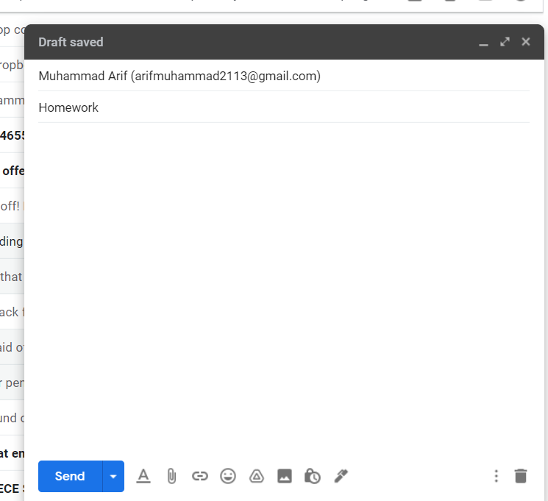

Task 2: Searching for an email

Non-technical description: In your email’s search bar, you type in words that appeared in the email you are searching for. This returns all emails that were sent to you that include the words you searched for. There are also search options where you can search by sender’s email address, by the subject field, whether it does not have certain words, includes an attachment, and within dates.

Technical Description of the task: Email implements a search engine that uses the provided criteria from users to read through all received emails and pull out and list the emails that the user searched for. For different search criterions, different algorithms are used by the email application to find the relevant messages.

What can go wrong while completing the task: If a user has deleted a received email unintentionally and it has been in the trash folder for more than 30 days, it is likely that it will be unrecoverable. When you attempt to search for the email, you will not see it.

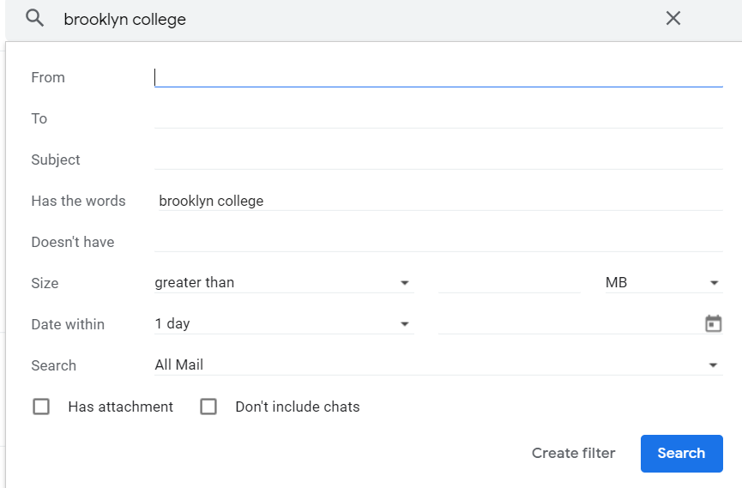

Task 3: Receiving spam emails

Non-technical description: Spam emails are unsolicited “junk” emails that are sent in bulk and not wanted. These can be commercial emails that are sent in bulk to email addresses for the purpose of buying the spammed product or service. This is also done because it is cheaper to advertise compared to other advertising means.

Technical Description of the task: Spam emails are sent by a spammer which is hired by a business to generate email advertisements to unsuspecting recipients. Emails that are spammed to are found from harvesters who save email addresses from websites and other places. Emails automatically place these type of emails in a spam folder which includes all spam emails that were sent to user.

What can go wrong while completing the task: A sender can email a user several times about the same thing and it can be considered spam. These emails could be of importance to the receiver yet the email application can mark it as spam if it appears to look as spam.

